Missionaries and Cannibals Problem Using Python

Aim
To develop a Python program to solve the Missionaries and Cannibals problem using the Breadth-First Search (BFS) algorithm.

Objective
To find a safe sequence of moves that transports three missionaries and three cannibals from the left bank to the right bank without allowing missionaries to be outnumbered.

Algorithm
1. Represent state.
2. Initialize start and goal.
3. Generate valid moves.
4. Validate states.
5. Use BFS.
6. Display solution.

Flowchart


Python Program
from collections import deque

# Function to check whether the state is valid
def is_valid(m_left, c_left):
m_right = 3 - m_left
c_right = 3 - c_left

if m_left < 0 or m_left > 3 or c_left < 0 or c_left > 3:
return False

if m_left > 0 and c_left > m_left:
return False

if m_right > 0 and c_right > m_right:
return False

return True

# Breadth First Search
def bfs():
start = (3, 3, 'L')
goal = (0, 0, 'R')

queue = deque([(start, [start])])
visited = set()

while queue:
state, path = queue.popleft()

if state == goal:
return path

if state in visited:
continue

visited.add(state)

m, c, boat = state

moves = [
(2, 0),
(0, 2),
(1, 1),
(1, 0),
(0, 1)
]

for dm, dc in moves:

if boat == 'L':
new_state = (m - dm, c - dc, 'R')
else:
new_state = (m + dm, c + dc, 'L')

if is_valid(new_state[0], new_state[1]):
queue.append((new_state, path + [new_state]))

return None

solution = bfs()

print("Missionaries and Cannibals Solution")
print("-----------------------------------")

for i, state in enumerate(solution):
print("Step", i, ":", state)

Sample Output
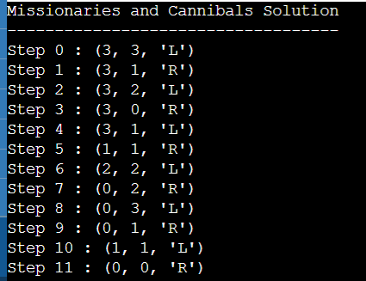

Result
The problem was solved successfully using BFS.

Conclusion
BFS efficiently finds a valid solution while satisfying all constraints.

